Project Design Phase
Solution Architecture

Date | 15 February 2025
Team ID | LTVIP2026TMIDS76616
Project Name | HematoVision – Advanced Blood Cell Classification Using Transfer Learning
Maximum Marks | 4 Marks

Solution Architecture:
The solution architecture of HematoVision defines how the system components interact to provide automated blood cell classification using Artificial Intelligence.
The architecture bridges the gap between the healthcare problem (manual blood cell analysis delays) and a technology-driven AI solution using deep learning.
- Automate blood cell classification using AI.
- Reduce manual workload of lab technicians.
- Provide faster and accurate diagnostic support.
- Ensure scalable and secure web-based deployment.
Example - Solution Architecture Diagram:
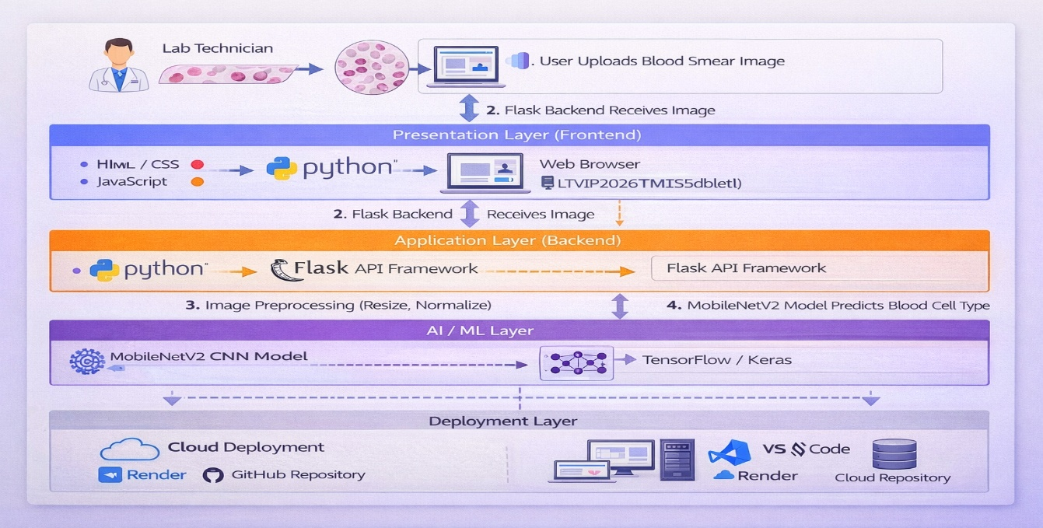

Figure 1: Architecture and data flow of the voice patient diary sample application
Reference: https://aws.amazon.com/blogs/industries/voice-applications-in-clinical-research-powered-by-ai-on-aws-part-1-architecture-and-design-considerations/

